**Midterm Exam: PART** **B**

Sample:

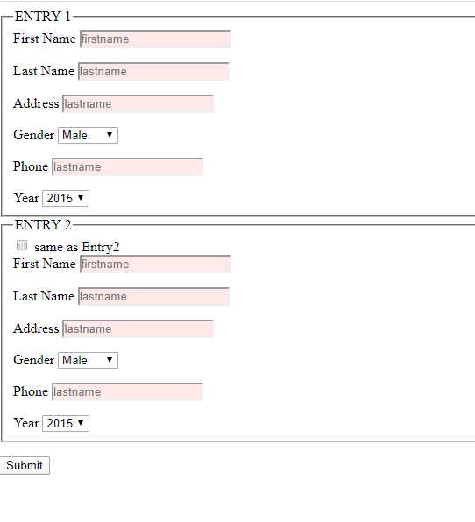

1. Create an html and JavaScript file to transfer or copy data from one field to another based on user indicating they should have the same value -  **5marks**

Example: Shipping Address and Billing Address

**Sample:**

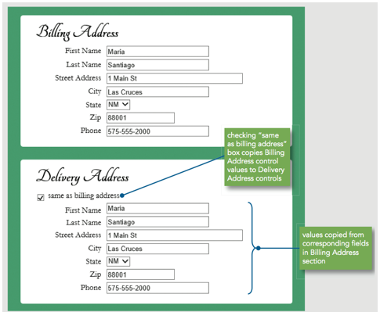

1. Create a custom browser-based validation feedback using the following
   1. checkValidity() and setCustomValidity() methods  **2.5 marks**
   2. CSS :invalid and :valid pseudo-classes  **5 marks**
2. selectedIndex = -1  **5 marks**
3. use placeholder **2.5 marks**

To change properties of form elements based on validity status.

**Sample:**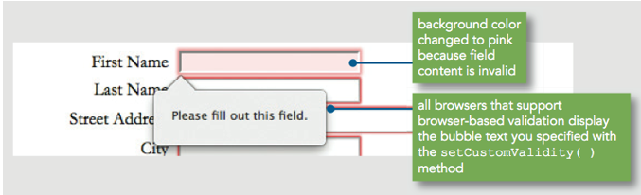

**Ensure all your files are in the same folder. Upload the zip folder into Mid-Term drop box.**